CUCUMBER UPDATED FILE

- CREATE MAVEN PROJECT:

File-> new-> Mavin project-> next-> enter maven-archetype-quickstart in filter box-> select appache option 3rd option-> next-> enter group ID and Project name and package-> finish-> enter y in consol and press enter now project got created

- Delete Packages from src/main/java and src/test/java:

- Create Features (src/test/resources): Here only we write test cases

- Right click on main project – New - Source Folder - src/test/resources - Finish
- src/test/resources - Right click – New – Package - features – Finish
- features - right click - New – file - Login.feature

- Add Dependency’s: (pom.xml)
Note: Copy the pom from z-cucumber project after that right click on main project – maven – update project – click force update check box - ok

- Now write test case inside all feature file(Create feature file)

Note: This 5th step is as of now only later change will happen

- Method 1 using: string “ “:
Note: Now at this stage the test case will be like this only scenario and “” will be there so as of now in all steps “ ” string is used. Later we will change the code in upcoming steps

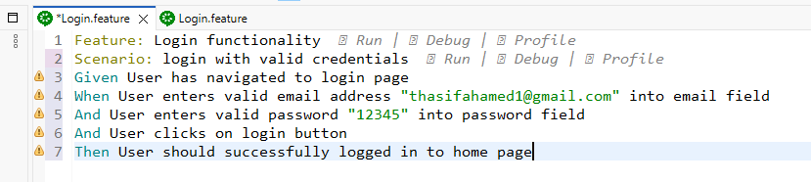

For String Snippet code will be like this below:
@When("User enters valid email address {string} into email field")
public void user_enters_valid_email_address_into_email_field(String validEmail) {
driver.findElement(By.xpath("//input[@id='input-email']")).sendKeys(validEmail);
}

- Method 1 using: Data table |||:
Note: Always remember don’t use same email id it will throw error. Now I used email latter I will remove it

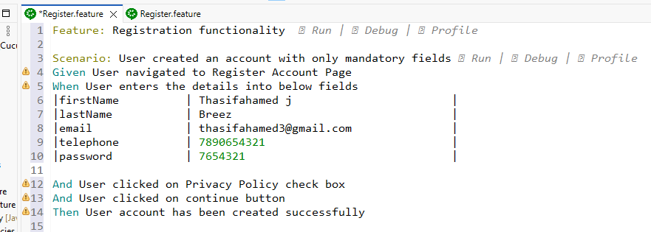
Use common method: This will change mail and password every time when run the code so after adding common method remove email from feature file steps
@When("User enters the details into below fields")
public void user_enters_the_details_into_below_fields(DataTable dataTable) {

}

- Implementation of all features(Create class): Step Definition - Snippet

- src/test/java – new – package – stepdefinitions – finish // create package
- Stepdefinitions – new – class – Login – Finish // create class inside package
- Open login.feature – Right click – run - Cucumber Feature – Always save – Ok – output created automatically in consol – copy op from console and paste inside login class but change that when, given, then it will not come correctly

Note: this step will give you snippet in console copy and paste in java class
WRITE LIKE THIS: SAMPLE CODE FOR SETUP INSIDE SNIPPET in all java class:

import io.cucumber.java.en.*; import this

@Given("User has navigated to login page")
public void user_has_navigated_to_login_page() {
System.out.println("Done");
}

As of now don’t write selenium code in any snippet after creating hooks then fill the code
----------------------------------------------SET UP DONE---------------------------------------------------

- Global Program:

2) Create Hooks package: please find 1st step below page then come here
Note: What this will do means here as of now we will write the before and after method to open the browser and move into app and close the browser. After writing this code in hooks package write selenium code in all the java class snippets by calling this before and after method this method will run before and after all the scenarios
- src/test/java – new – package – hooks
- hooks – new – class – MyHooks
As of Now Pic:
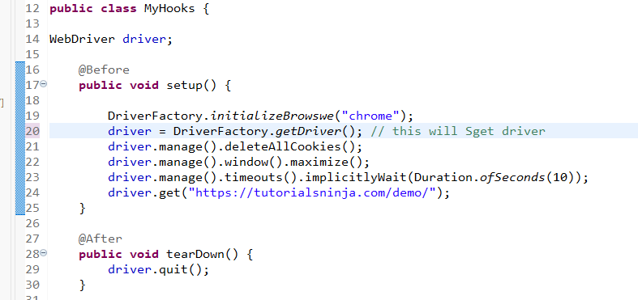
- Create Driver Factory package:

- src/test/java – new – package – factory
- factory – new – class – DriverFactory

As of Now Pic: below

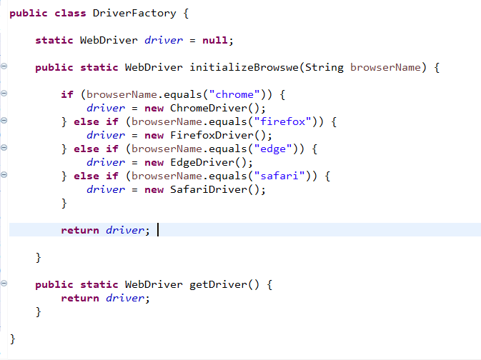
Note: Copy this code from z-cucumber project

- Call driver from driver factory in all the created java class:
Note after calling the driver then write selenium code as per below image
driver= DriverFactory.getDriver(); // call this line in every java class this will open and close the browser and application after completing each and every scenario start and end

As of Now Pic: below

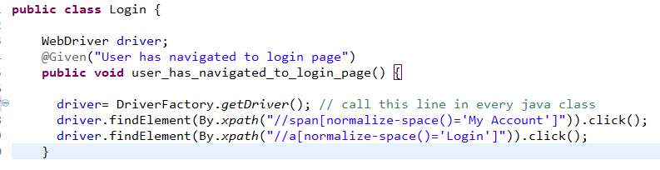

- Write Selenium Assert Codes:
Note: In Assert true condition also has to be true to pass the test
- isDislpay():
Assert.assertTrue(driver.findElement(By.xpath("")).isDisplayed());
- Assert.assertTrue () . getText().contains()
Assert.assertTrue(driver.findElement(By.xpath("")).getText().contains("Warning: No match for E-Mail Address and/or Password."));
Note: enter the x path of the text which given inside contains
- Assert.assertEquals(); : . getText());
Assert.assertEquals("First Name must be between 1 and 32 characters!",
driver.findElement(By.xpath("//div[contains(text(),'First Name must be between 1 and 32 characters!')]")).getText());
Note: enter the x path of the text which given inside contains
- SendKey();
Method 1: This is Date Table Method: |firstName | Thasif |
public void user_enter_the_details_in_below_fields(DataTable dataTable) {
Map<String, String> dataMap =dataTable.asMap(String.class,String.class); // syntax
driver.findElement(By.xpath("//")).sendKeys(dataMap.get("firstName"));
}

Method 2: This is Normal String Method
public void User_enters_valid_email_address_into_email_field(String validemailText)
{
driver.findElement(By.xpath("//")).sendKeys(validemailText);
}

- Common code sendkey to change email and password in every time running:

Common Date change code use in email and password
public String getNewChangeEmail() {
long timestamp = System.currentTimeMillis();
return "thasif" + timestamp + "@gmail.com";
}

Note: Remove the email from feature steps and email will be like this in snippet below

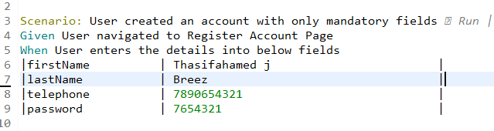

driver.findElement(By.xpath("//input[@id='input-lastname']")).sendKeys(dataMap.get("lastName"));

driver.findElement(By.xpath("//input[@id='input-email']")).sendKeys(getNewChangeEmail());

-----AS OF NOW FILL ALL JAVA CLASS SNIPPET WITH SELENIUM CODE IN ALL FEATURES-------

- Create Runner file:
Note: This runner class will help us to run all the feature files at the same time that’s why we create runner file
- Right click src/test/java – new – package - runner – finish
- Runner – new – class – MyRunner – finish

As of Now Pic: below
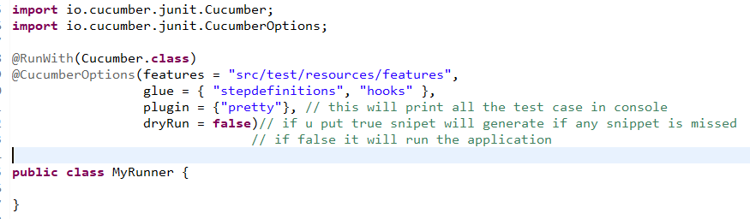

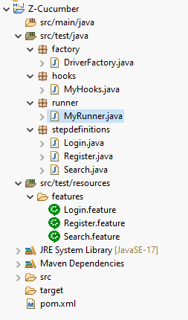

--------------------------------------AS OF NOW RUN ALL THE FEATURES------------------ -----------------

- Remove Hardcode:

- Remove hardcode from MyHooks for Browser and URL:

- Src/test/resources – new – package – config – finish
- Config – new – file - config.properties – finish
Note: As of now remove browser and URL
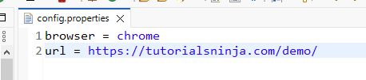

- Bring above Properties file inside ConfigReader class:

- Src/main/java – new – package – utils – finish
- Utils – new – class – ConfigReader – finish

Note: This below step is fully syntax this will not change only later we will remove static if needed only

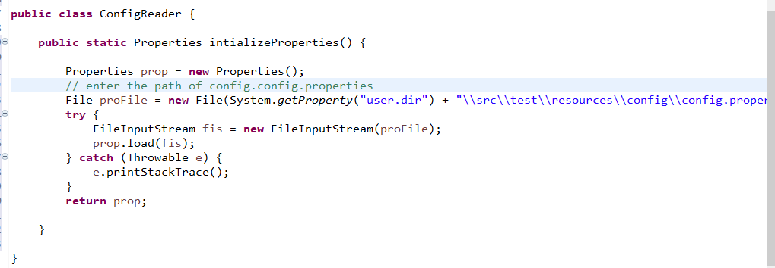

- Now Call the above ConfigReader class in MyHooks class:

Note: After completing the above 2 steps now come back to myHooks class and remove the hardcode from browser and URL. Now we removed hardcode of browser and URL in line 21, 22, 27 changes happen
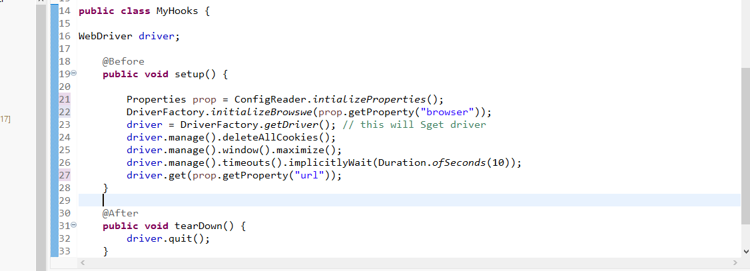

Properties prop = ConfigReader.intializeProperties(); //call
DriverFactory. initializeBrowser(prop.getProperty("browser"));
driver.get(prop.getProperty("url"));

- Now remove the common email and password methods from java class and add into utils package CommonUtils class:

- Src/main/java – utils – new – class – CommonUtils

Sample Image is below // Remove common code of email and password date changer code from java class and move that into commonUtils class and then call this method in java class
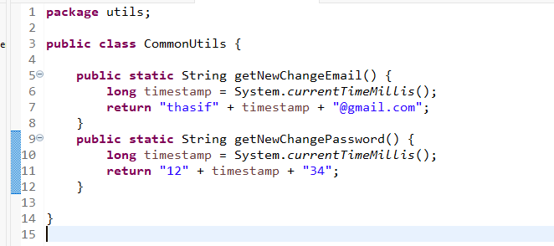

Note: After creating this class call this class in java class where we used changeEmail and changePassword using this class name

Before Calling CommonUtils class in Java class see last line in both method:
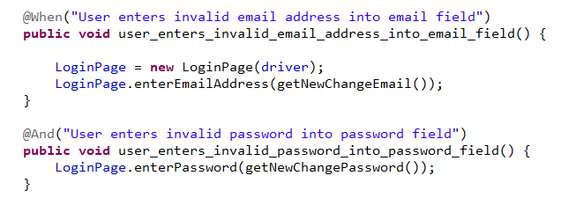
After Calling CommonUtils class in Java class see last line in both method:
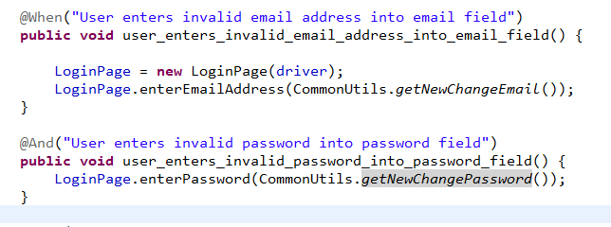

- Remove Hardcode of locators from snippets and put in Page class:
This Step is POM CLASS in Kiaq project:
- Src/main/java – new – package – pages
- Pages – new – class - HomePage

- Without Calling POM object globally:

Note: Now what is going to happen is we will remove the xpaths from all java classes and put that xpaths in pages class below image is syntax before we bring selenium code and in this Home page class code will not change so we can refer code from cucumber project for understanding

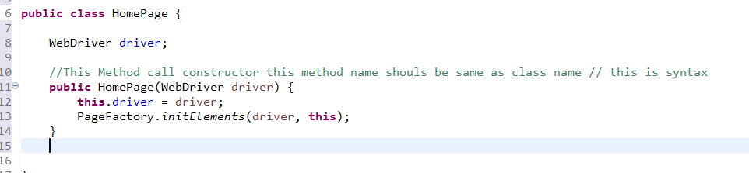

POM CODE SAMPE IMG:
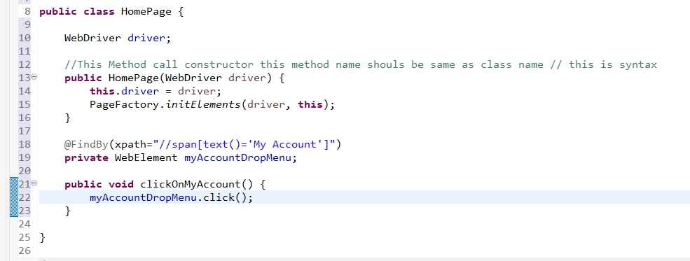

Note: After we wrote pom code call that object inside java class see below picture:

Before adding POM method in login class will be like this:
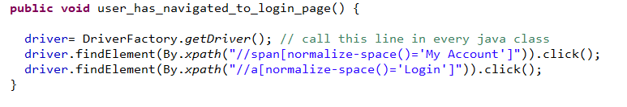

After adding POM method in login class will be like this: As of now
Call this object:
HomePage homePage = new HomePage(driver); // call object
Remove:
driver.findElement(By.xpath("//span[normalize-space()='My Account']")).click(); // done
Because for this line only we wrote code in HomePage class and now by using homepage object we can call this step from homepage class
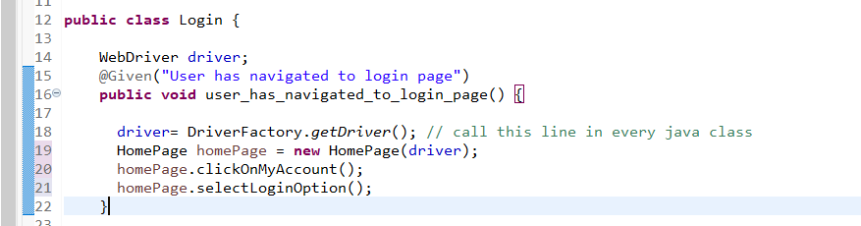
POM CODE USING STRING:
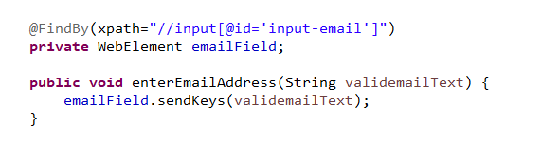

Before adding POM method in login class will be like this: this is String
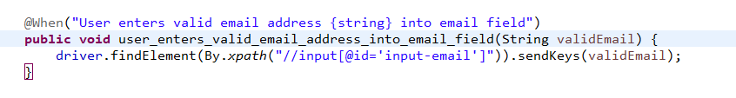
After adding POM method in login class will be like this:
Call this object:
LoginPage LoginPage = new LoginPage(driver);
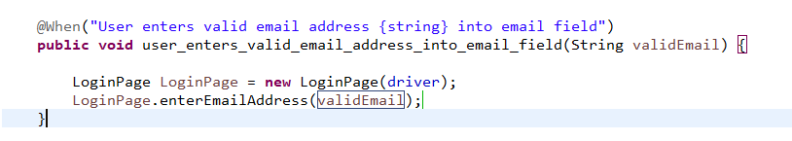
Note: As of now we haven’t called the objects globally in upcoming steps we will call the object globally

---------------------------AS OF NOW WE CREATED POM NOT CALLED GLOBAL------------------ -----------------
- Calling POM object globally in private:
Before calling object globally it will not show the methods so call the object globally
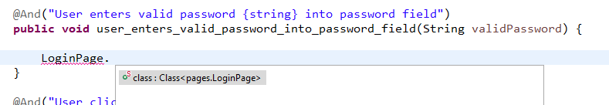

See method not showing
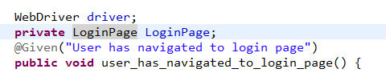

In line 2 you can see I called login object globally so I can now use the method in latter it will also change as of now use this and use private in global calling

---------------------------AS OF NOW WE CREATED POM AND NOW CALLED GLOBAL------------------ --------

- In POM object for isDisplay use Boolean this is in page class:

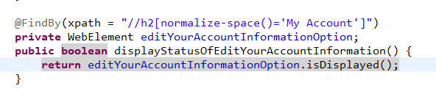

Before Login class code inside snippet in assert:

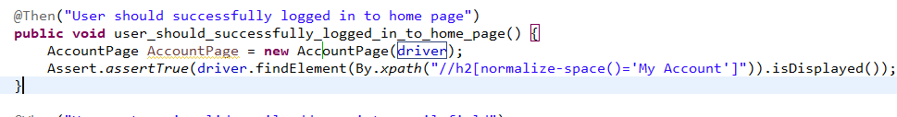

After Login class code inside snippet in assert:
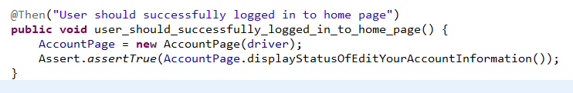

- Assert.assertTrue () . getText().contains()

This is in Page class
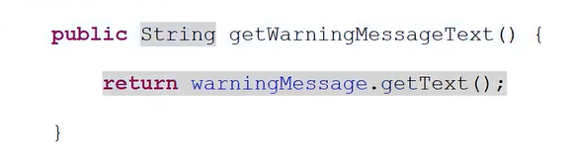
This is in java class
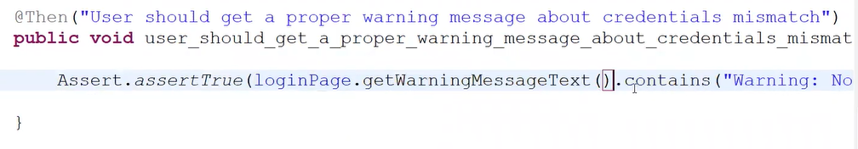

- In Java class email after change common code in POM:
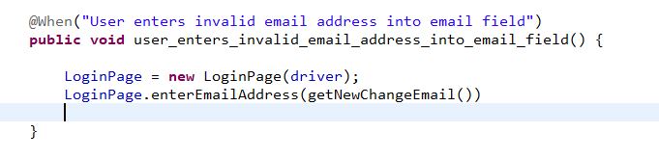

- If u don’t enter email or password:

If u dont enter email id and password just call that object don’t leave empty then it will throw error

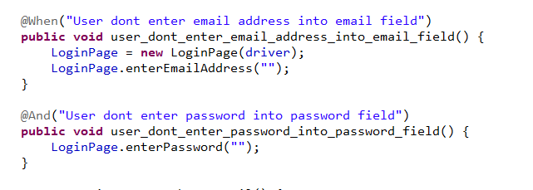

Note: Before every assert call the relevant object again

- Data Table Page class and Java class:

Note: POM class as usual

@FindBy(xpath="//input[@id='input-firstname']")
private WebElement firstNameField;
public void enterFirstName(String firstNameText) {
firstNameField.sendKeys(firstNameText);
}

Before Register class code inside snippet in Data table:

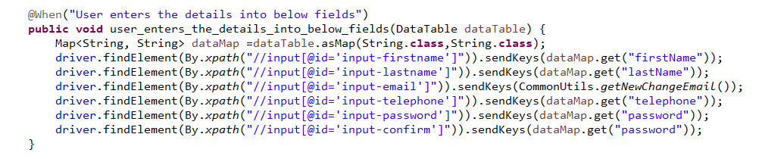

Note: The above image is before we create page class for data table

After Register class code inside snippet in Data table:
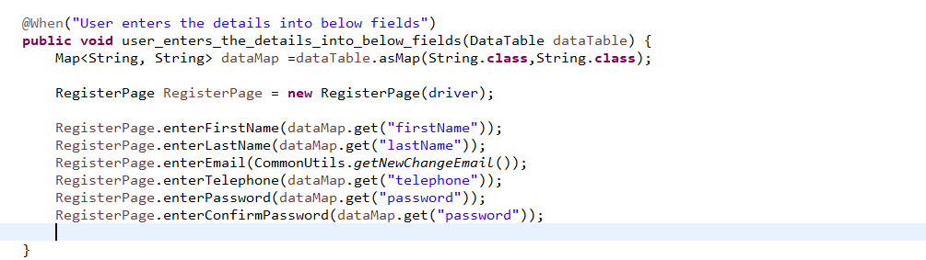

------------------------AS OF NOW REMOVED XPATH FROM ALL JAVA CLASS------------------ --------

- Optimisation

- Move code from @before method hooks to DriverFactory class
Note: Go to MyHooks then move below 3 lines of driver steps from @before method into driverfactory class inside initializeBrowswe class : Remove below 3 lines and add in initializeBrowswe class

driver.manage().deleteAllCookies();
driver.manage().window().maximize();
driver.manage().timeouts().implicitlyWait(Duration.ofSeconds(10));

Before Hooks:
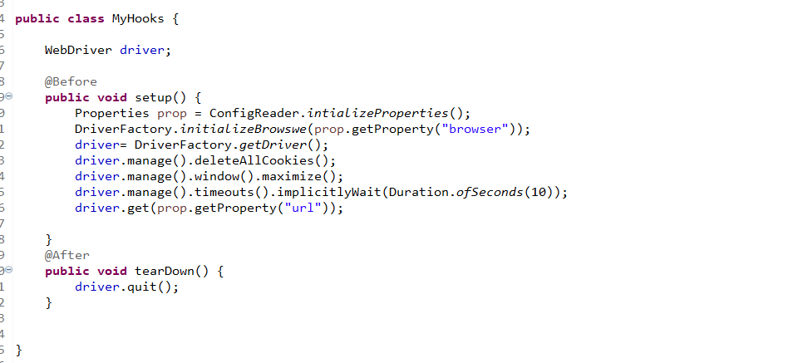
After Hooks: driver= DriverFactory.getDriver(); Remove this line 2 in hooks
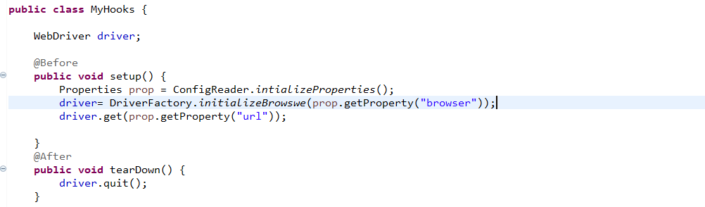

Before initializeBrowswe:

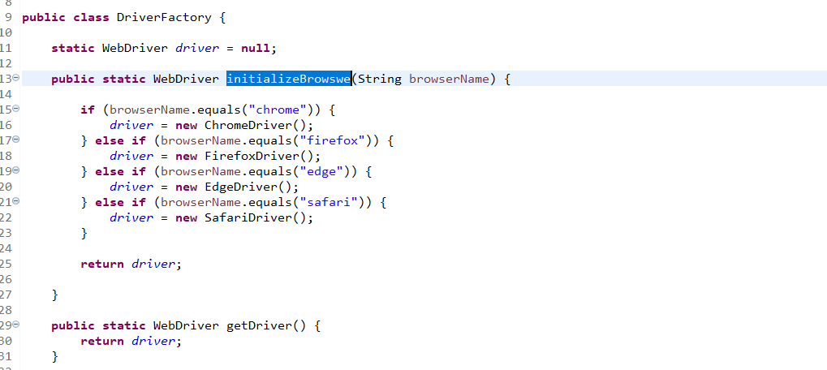

After initializeBrowswe:
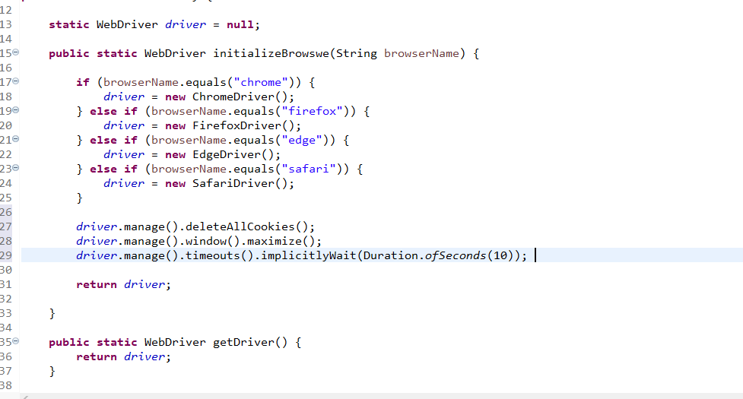

- Remove all the page Objects from all Java class
Note: Before this step we used to call respective objects before all the snippets method starts. But this step will help us to remove the object before all the step and put globally once

- Go to Register.java
- Remove these object
homePage = new HomePage(driver);
loginPage = new LoginPage(driver);

Before Register.java:
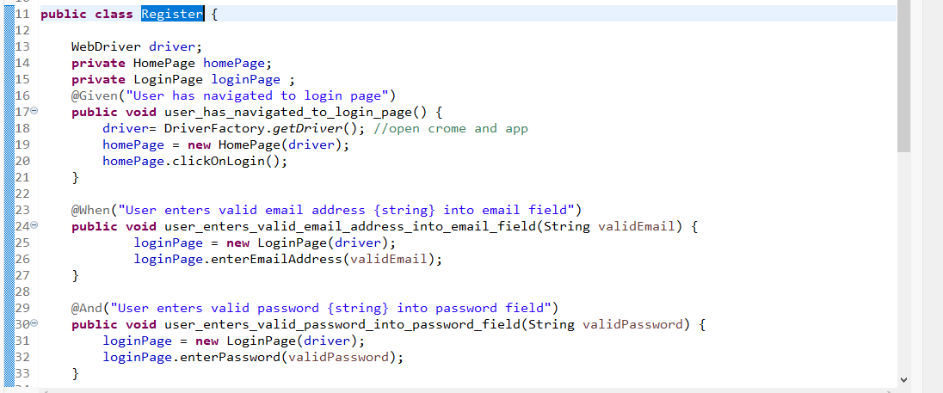

Note: How it will work means when we move to next page class in that before method last step we need to do this process. Here note line 20 and 25 as of now in 20 lines go to that page class go to clickOnLogin method in homePage class pom

Before POM:
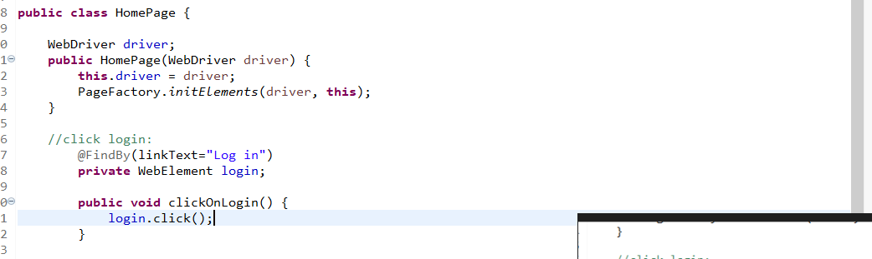
Note Line 2 as of now
After POM:
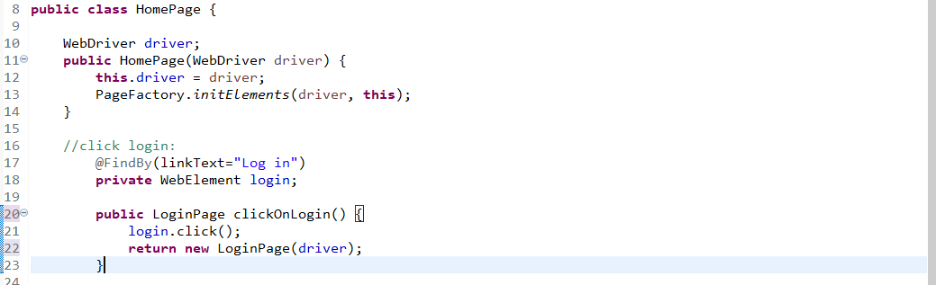
Note Line 22 now I added return new LoginPage(driver); and return LoginPage

After Register.java:
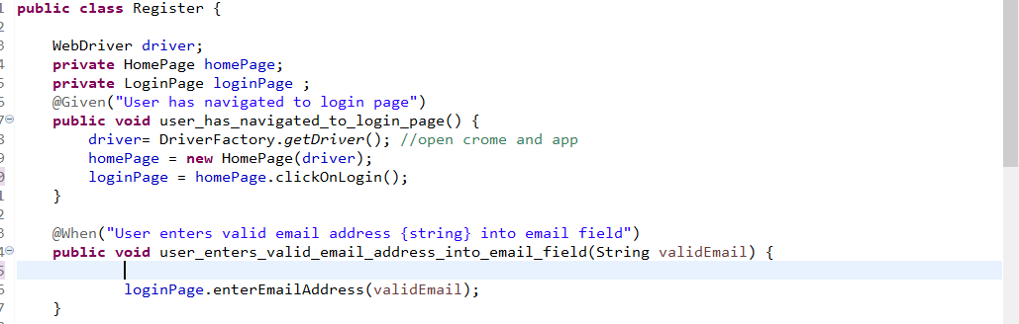
Note: I removed loginPage = new LoginPage(driver); and now Please note line 20 loginPage = homePage.clickOnLogin(); loginPage is called and now I removed line 25. This is how we will remove all the objects call reputedly

Note: do like this if u have doubt 4:16 u can see in YouTube

------------------------AS OF NOW REMOVED OBJECTS FROM ALL JAVA CLASS------------------ -------

- MyRunner class Setup:

- Plugin = “pretty”:
In MyRunner add plugin: This plugin will help us to print the test cases in console which we wrote in feature file without using sysout. If that step is pass it will come in green if fail it will come in red if skip it will come in orange colour
- dryRun = false: this will be in true by default
If you use true it will create missed snippet in console if any test cases are not executed. If you use in false then it will run the full application

- Create HTML report inside target folder

- plugin = {"pretty","html:target/CucumberReports/CucumberReports.html"}

- This will generate html report in target folder.

- After this run the project once again and then refresh the project now the html report will be under target folder

- Then right click on that html report open with web browser it will come like this
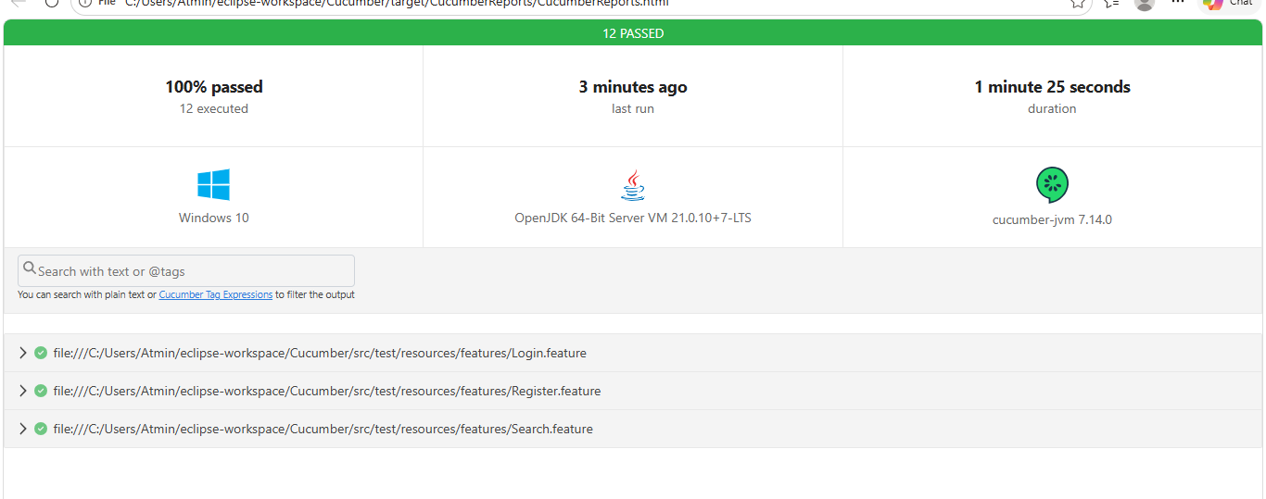

- Now MyRunner class will be like this see line 12
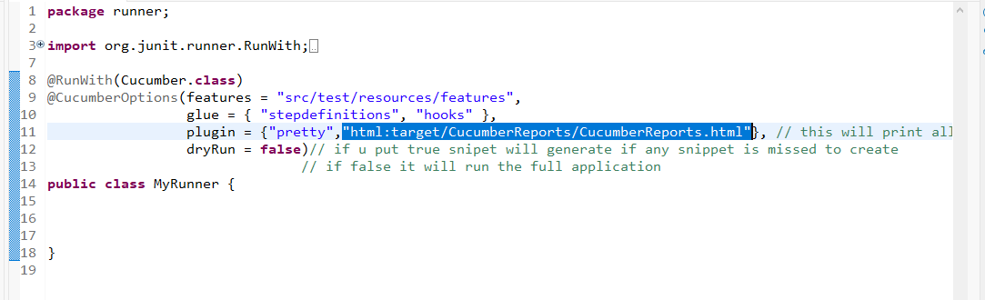

- Generate URL of this report: This report one day only will be there

- To share this report to the team or in cloud we have to generate the url. For that in myrunner class add below syntax
publish = true,
- After this syntax added in myrunner class again run the project
- Now after running the project in console it will generate URL link like this copy that link and remove unwanted words just keep http then run in browser it will generate URL report

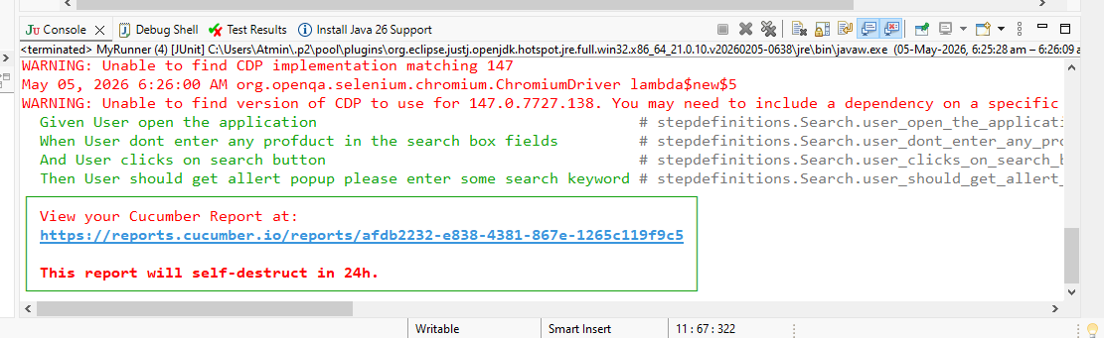

This is the URL Report:
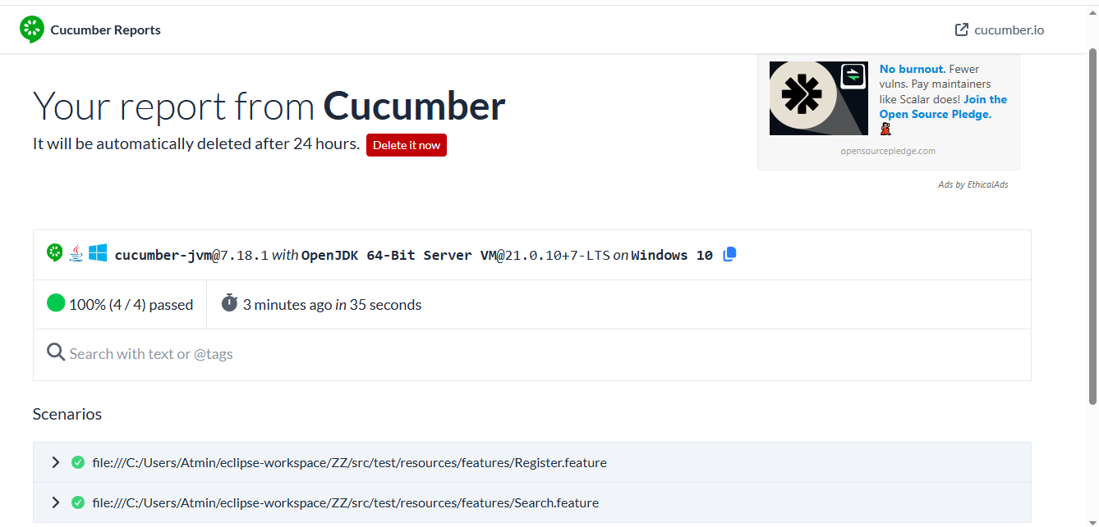
Now MyRunner class line 12:

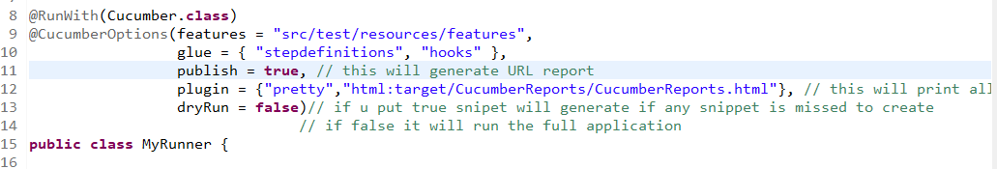
- Take Screenshot: (if any step got fail get the screenshot) 5:11 see

Note: to check this now I wontedly failing one step in search java class wither the screenshot coming in report or not I added Assert.fail();. This will work only I made mistake in snippets

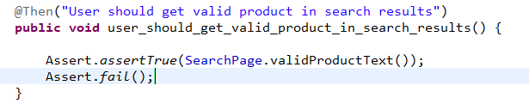

- Now again run the project from test runner now above step will be failed and throw error in URL report like this

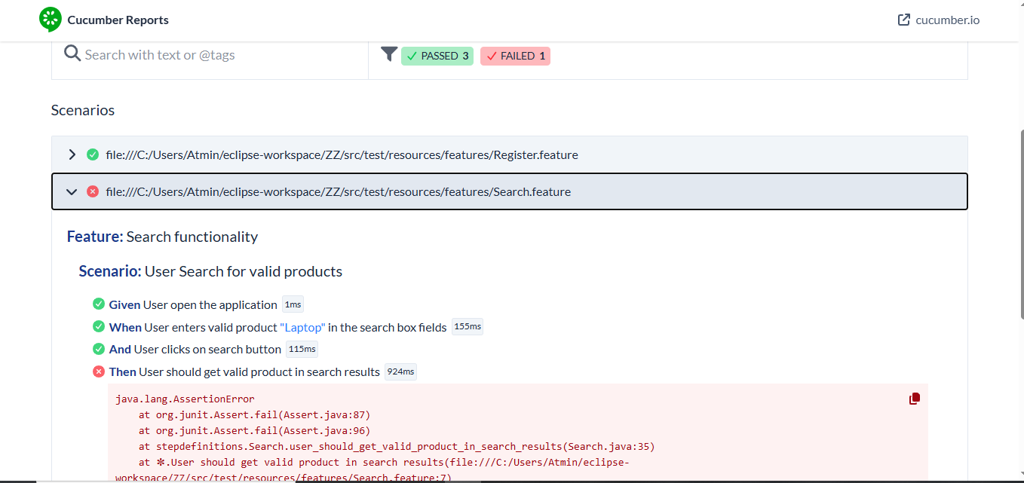

- Now for this only we need to take the screen shot
- Go to myHooks - @after method – copy and paste the below code

@After
public void tearDown(Scenario scenario) {
String scenarioName = scenario.getName().replaceAll(" ", "_");
if(scenario.isFailed()) {
byte[] srcScreenshot = ((TakesScreenshot)driver).getScreenshotAs(OutputType.BYTES);
scenario.attach(srcScreenshot, "image/png", scenarioName);
}
driver.quit();
}

Before Hooks class @After method:
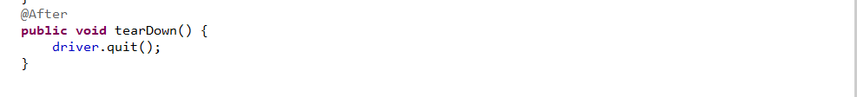

After Hooks class @After method:

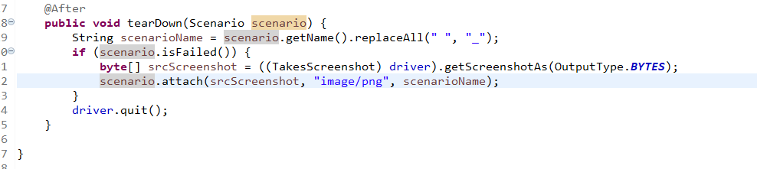
- Go to test runner class and run the project again then refresh the project then go to html report in target folder the open with browser the it will give the screenshot were the step failed like below:

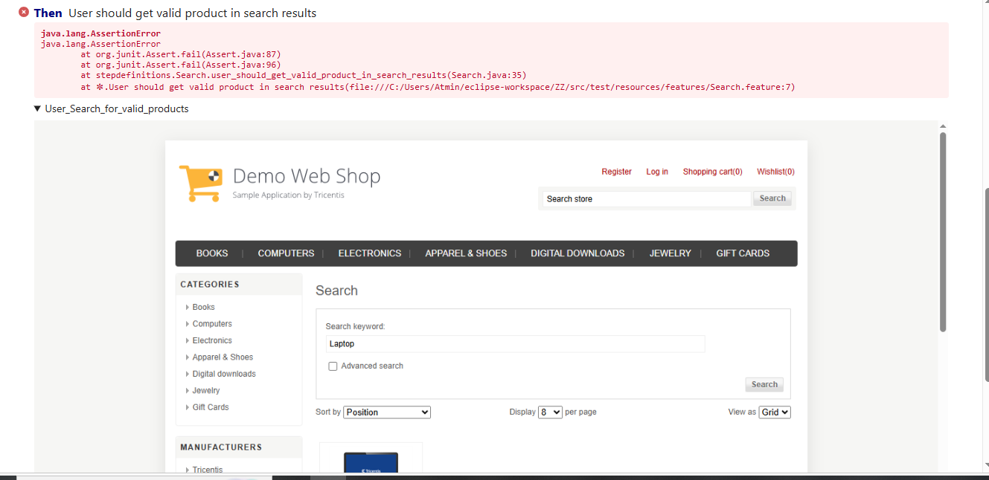

------------------------AS OF NOW GENERATE REPORT AND TAKE SCREENSHOTS------------------ -------

- Convert normal scenario to Date driven scenario: (This will convert normal cucumber project to hybrid cucumber project)
Note: What it will do means it will reduce writing multiple numbers of scenarios for the same steps
If we want to run 1 scenarios multiple times use this. These symbols ^ (.+) $ use inside snippet methods below code is there

- Go to Register.java – take 1st scenario and convert that into Data driven scenario

- Change Scenario to Scenario Outline 1st line
- Examples: last line. Here we will pass all data like tables |||
- Then remove the hard-core string data passing in test cases

Before Register feature file step:
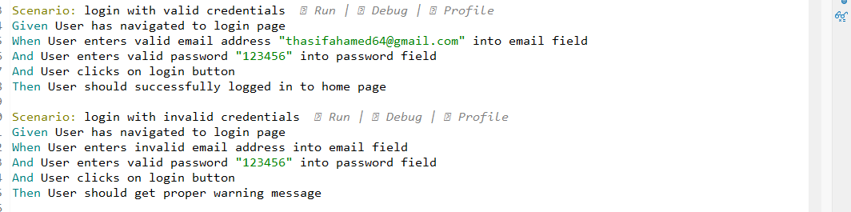
After Register feature file step:
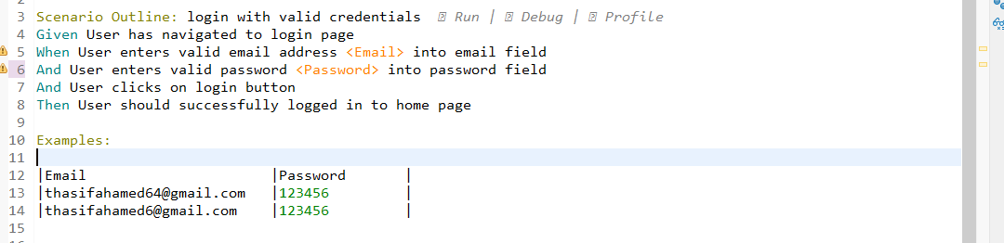

Note: After converting normal scenario to data driven scenario it will show this step not implemented in Register.java class. For that go to register.java and do the below changes

Before Register.java class:
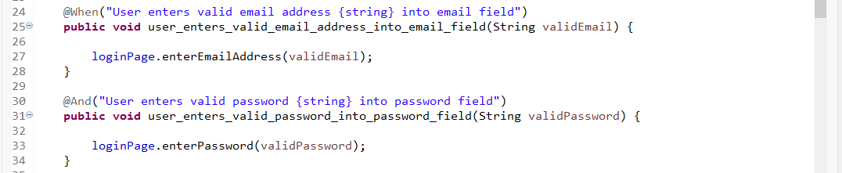
After Register.java class:
- We have to convert snippets remove the string from old snippets and add ^ (.+) $ these 3 symbols in old snippets so not the steps will be implemented

@When (“^User enters valid email address (.+) into email field$”)
public void user_enters_valid_email_address_into_email_field(String validEmail) throws Throwable {

}

@And (“^User enters valid password (.+)into password field$”)
public void user_enters_valid_password_into_password_field(String validPassword) throws Throwable {
}
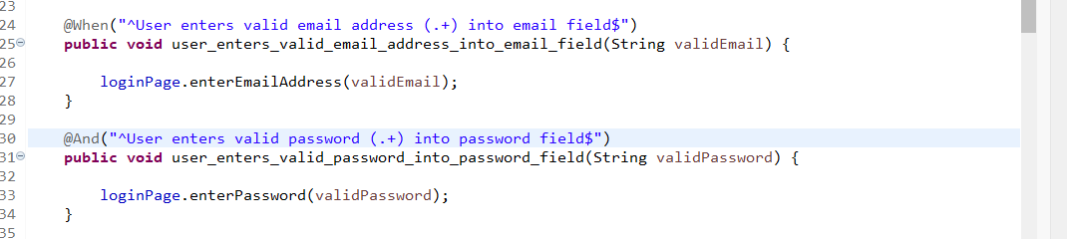

Note: After doing the data driven scenario the 1st scenario will run 2 times because in Example we given 2 valid email and password so it will run 2 times

--------------AS OF NOW CONVERTED NOEMAL SCENARIO TO DATA DRIVEN SCENARIO------------------

- Element utilities and constants

If any doubt in YouTube see 6th hrs. These change only happen in page class

- Element Utilities: This is the BassClass in kiaq project
Note: Create common methods in Element Utilities class copy this methods from zz cucumber project this code will not change apart from these methods you create even more methods if u want apart from this. This is only sample
- Src/main/java – utils – new – class – ElementUtils

- waitForElement method:
- clickOnElement method:
- typeTextIntoElement method
- selectOptionInDropdown method

Note: After creating these methods use these methods in all the java class. But we know we wrote all the xpath and methods inside page classes so we need to call this element Utilities class methods in respective page class

For example:
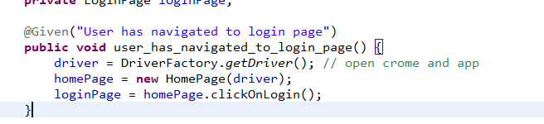

For this clickOnLogin(); we wrote real code in page class so go to that page and use the common methods which we created now in element Utilities class

Before Page class for clickOnLogin(); :
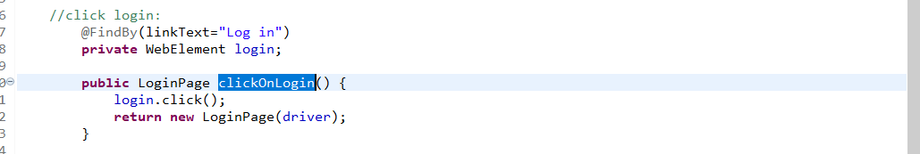

After Page class for clickOnLogin(); :

Step 1: call the element Utilities object in page class below webdriver driver; private ElementUtils elementUtils;
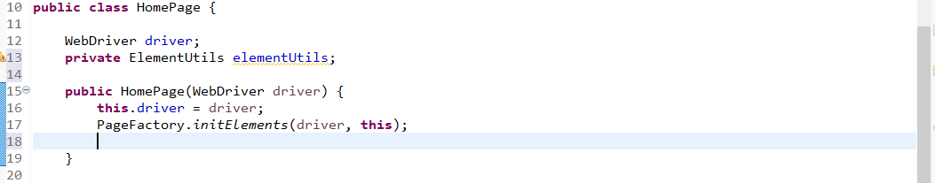

Step 2: Inside constructor create object for element Utilities object
elementUtils = new ElementUtils(driver);
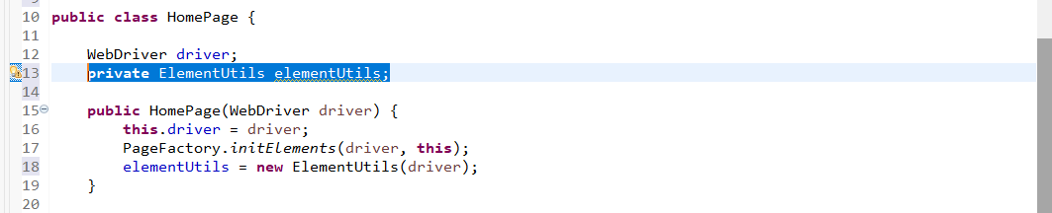
Step 3: Now in clickOnLogin(); call the created method from element Utilities
elementUtils.clickOnElement(login, 15);
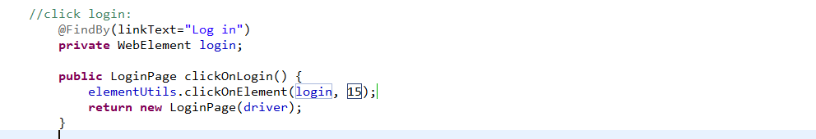

------AS OF NOW CREATED COMMON METHODS IN ELEMENT UTILS AND CALLED IN PAGE CLASS-----

- In Pom we will call list like this only

// User get the tag names of the svg element
@FindBy(xpath = "//*[name()='svg']/*")
List<WebElement> totalSvg;

// Getter
public List<WebElement> gettotalSvg() {
return totalSvg;
}

public void settotalSvg(List<WebElement> e) {
this.totalSvg = e;
}

